Thank you for participating in our article series !

In order to help us and allow us to share your experience, please take note of the following elements we need of publish your article efficiently :

- Provide us with a picture:
  - A colored one and of the best possible quality
  - A professional picture (like LinkedIn or resume picture)
  - NO selfie or non professional picture
  - If you do not have any picture, the ISIPCA ALUMNI logo will be placed

Before discovering the questions, here is a rendering of our publications on the various social networks - LinkedIn and Instagram:

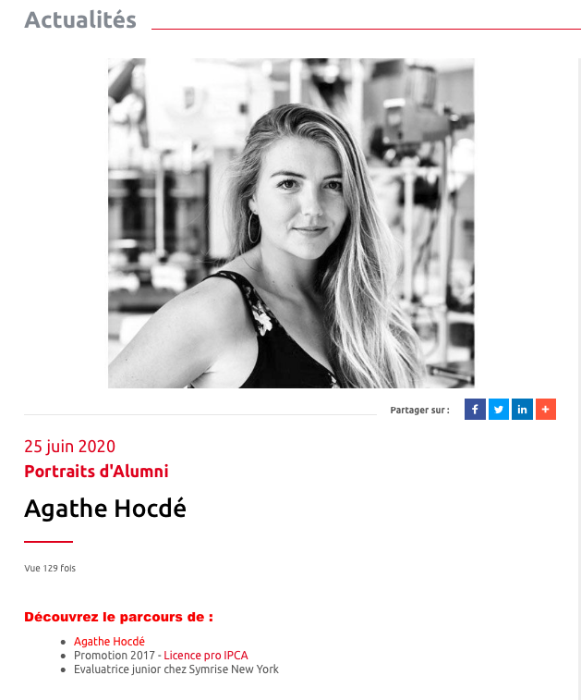

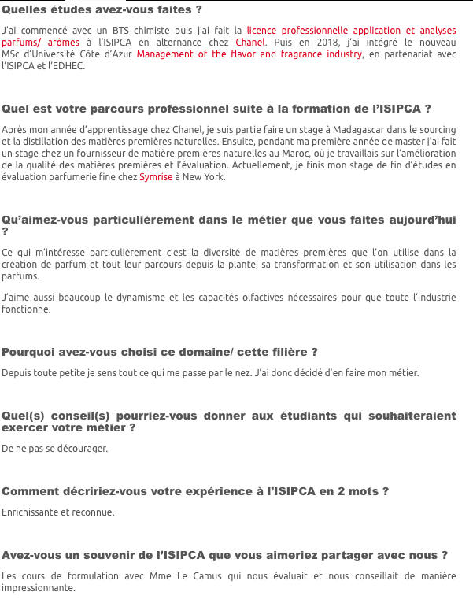
LinkedIn
Website

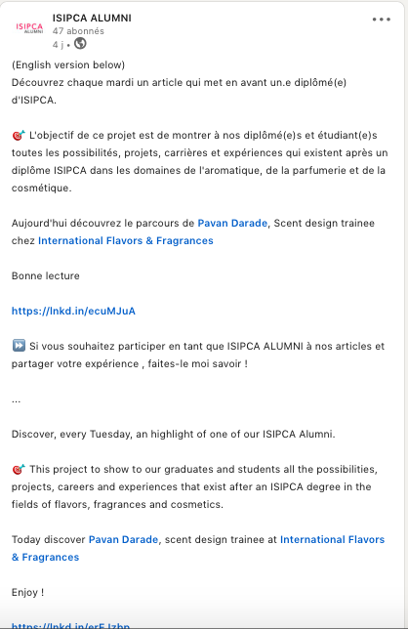
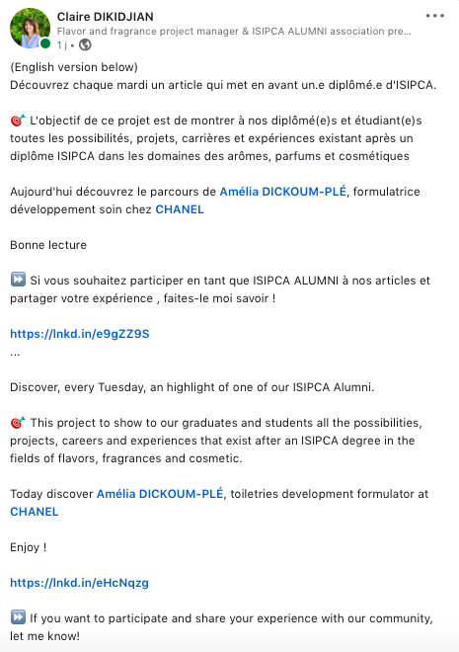

Instagram
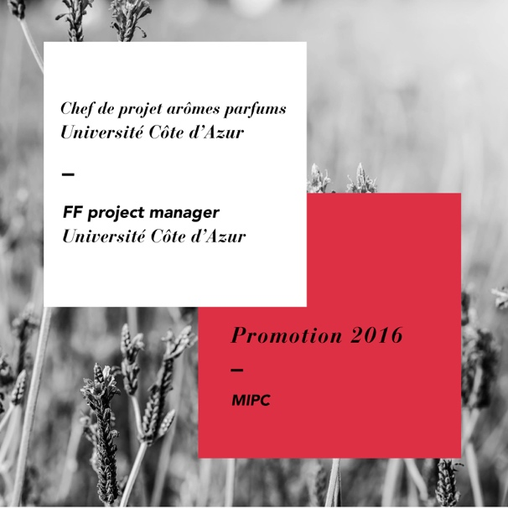
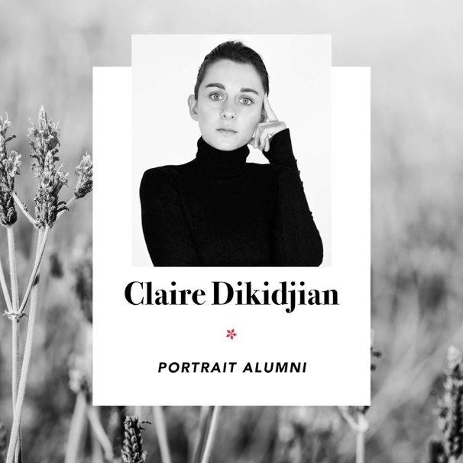

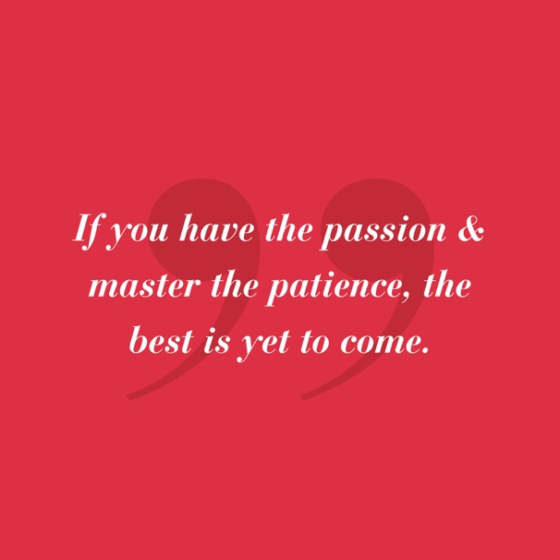
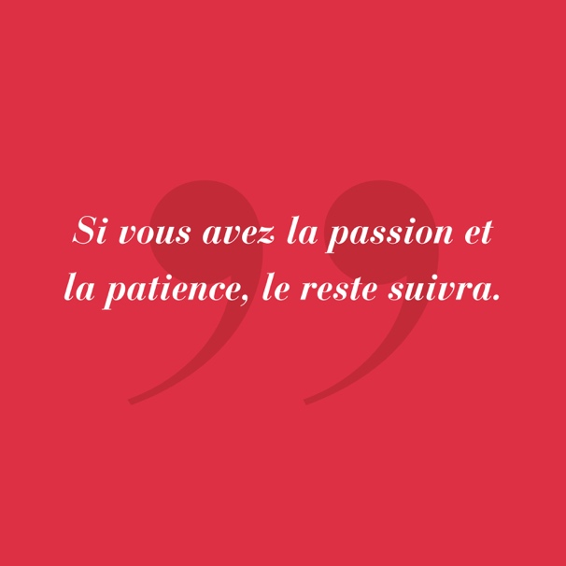

Here are the questions for the article :

- First Name Name (+ link of your LinkedIn profile)
- Promotion XXXX – Nom de votre diplômé
- Job title + Company name

What is your educational background ?
What is your professional path after your ISIPCA degree ?
What do you particularly appreciate about your current job ?
Why did you choose this industry ?
What advice (s) would you give to an alumni interested in your job
How would you describe your experience at ISIPCA in 2 words?
Do you have a memory of ISIPCA that you would like to share with us?

Once we receive your questions, we’ll read it, translate it in French and send your the final rendering in order to let you validate everything !

Send us back your story : contact@isipca-alumni.fr

